Cheatsheet: Processing User Input

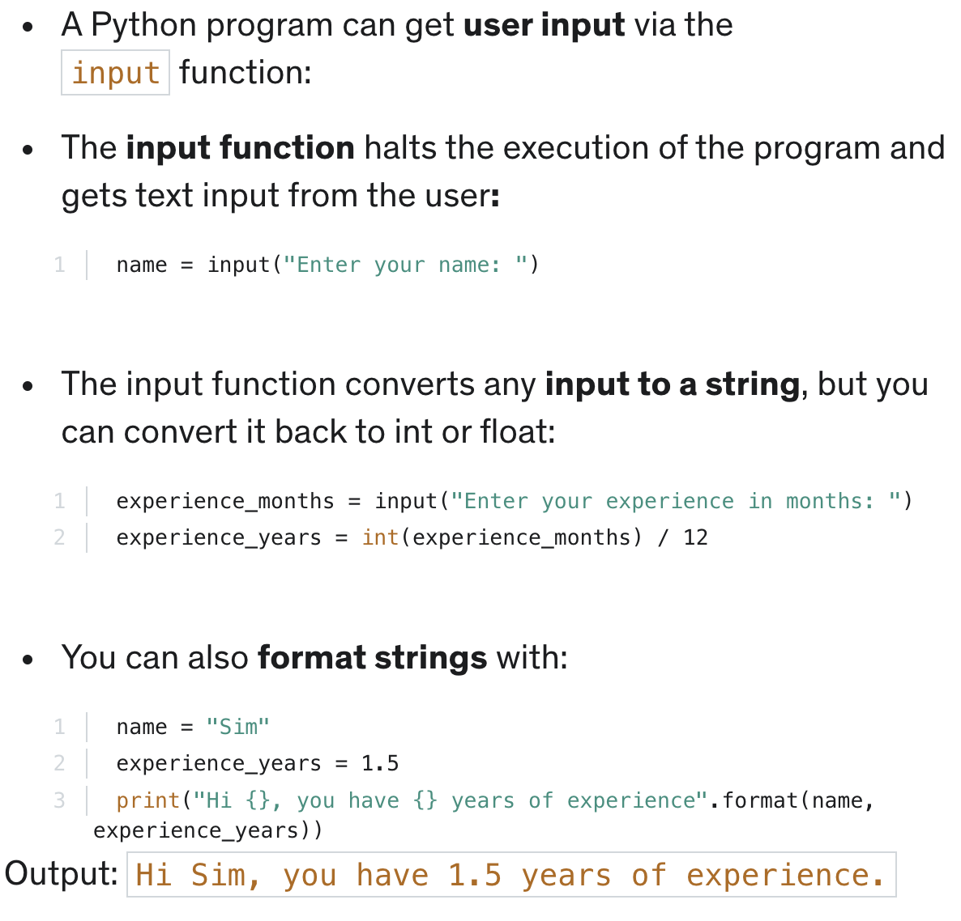
In this section, you learned that:

